2005

6. Historians often cite the harshness of the Treaty of Versailles on Germany as a primary cause of the eventual outbreak of World War II. Summarize two provisions of the Versailles Treaty relating to Germany and discuss how each helped lead to World War II. (4 points)

12. The Industrial Revolution brought about major changes not only in cities, but in rural America as well. Before machines were used, one farmer could harvest about 7.5 acres of wheat per year. With machines, he could harvest wheat on 135 acres. Scientists also developed new kinds of wheat seeds that could survive northern winters. These developments were examples of what was happening in many areas of agriculture.

Explain two additional ways farming changed as a result of the Industrial Revolution . (2 points)

18. Monarchies may be absolute monarchies or constitutional monarchies.

• Explain how monarchs usually acquired power under both types of monarchies;
• Describe what limits, if any, exist on how monarchs exercise power in both types of monarchies. (4 points)

24. Satellite-based communication systems allow people to communicate more easily. This increases the interdependence of nations around the world.

Describe how another advance in global communications or transportation contributes to the exchange of cultural practices. (2 points)

36. If the U.S. government wanted to encourage businesses to hire more employees, would the government raise taxes or lower taxes on businesses? Explain your answer. (2 points)

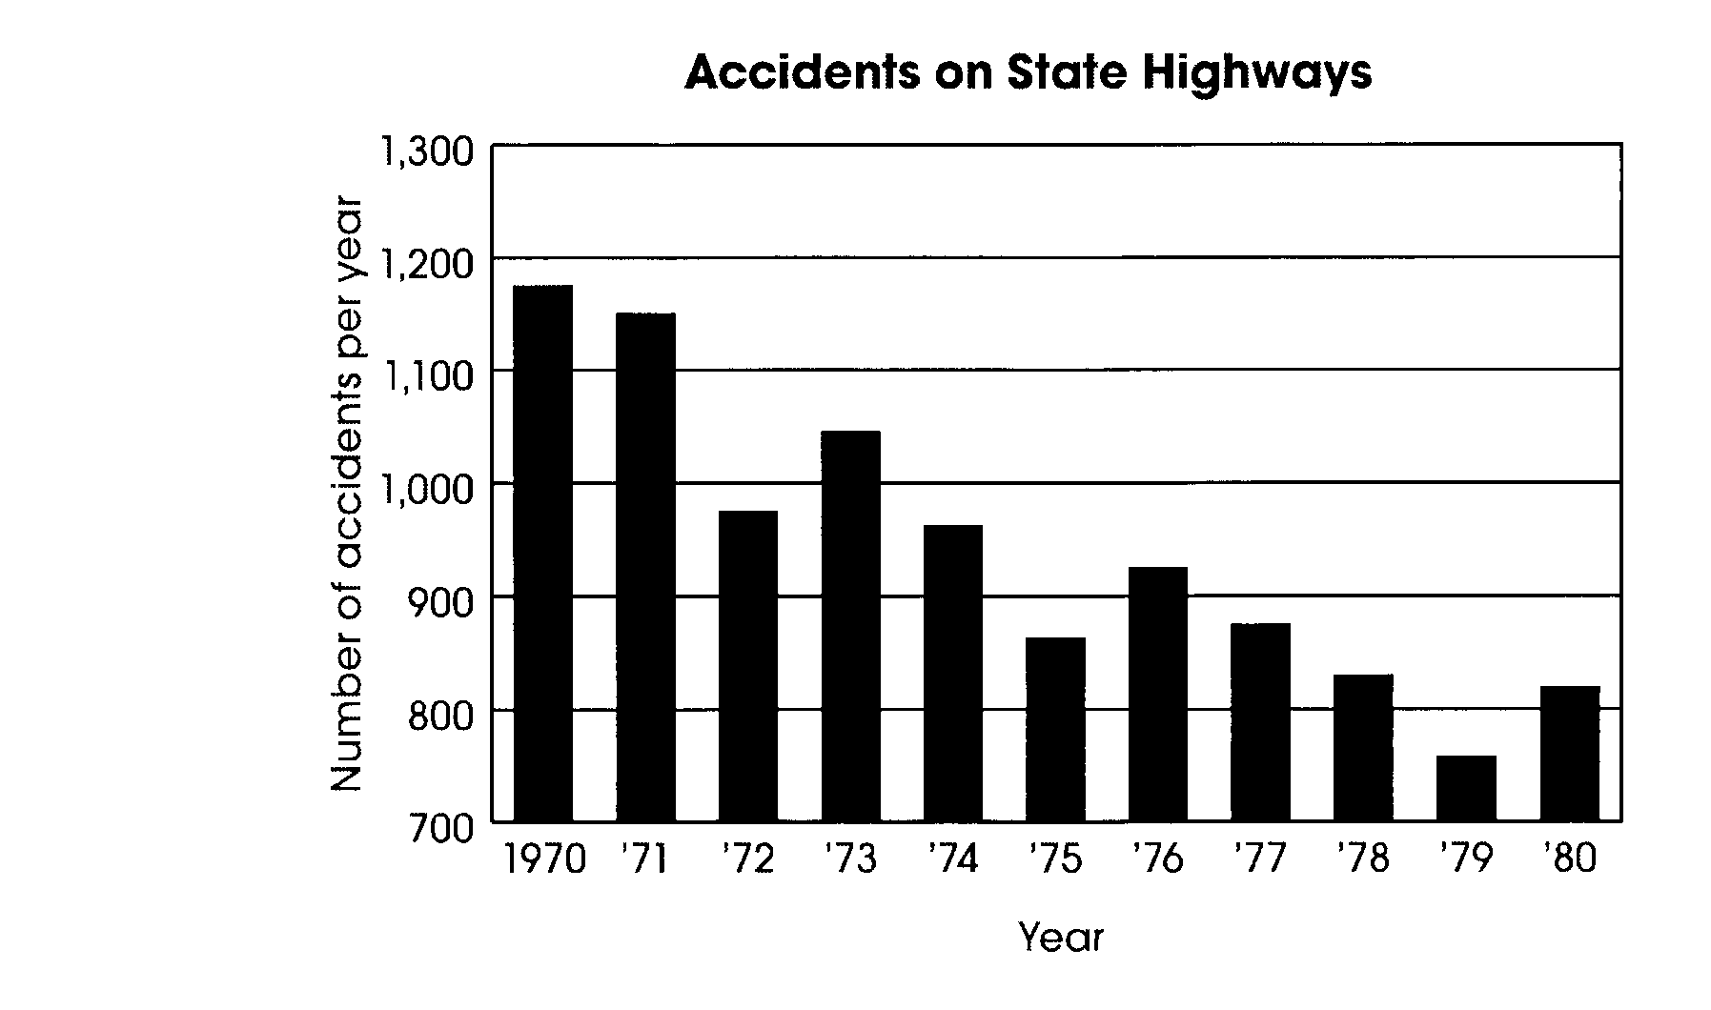
42. In 1970, a state government announced a program to reduce the number of state highway accidents to less than 1,000 per year within 10 years. In 1980, the state’s governor asserted that the goal of the accident reduction had not been met.

Using the data in the graph above, support or refute the governor’s assertion. (2 points)

2006

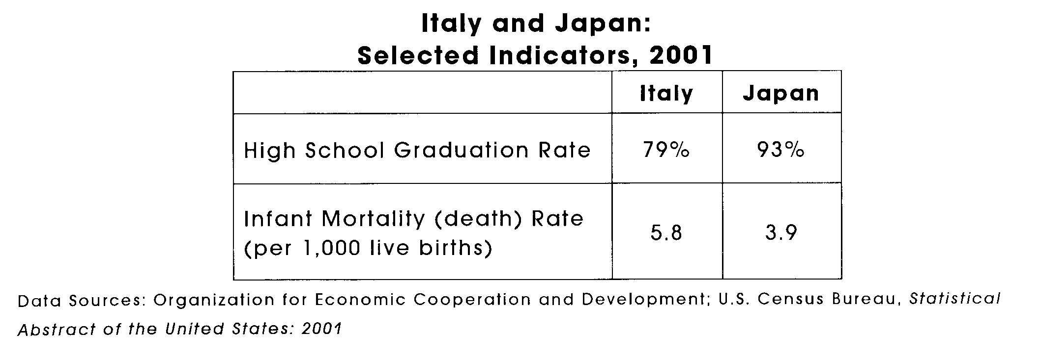
6. Using the data in the table above, support or refute the following thesis (2 points)

In 2001, Italy had a higher standard of living than Japan.

12. During the years between 1945 and 1950, the period directly following World War II, the Soviet Union expanded its influence in Central and Eastern Europe. (4 points)

• Describe two concerns the United States had about this expansion.
• For each concern, identify a related action taken by the United States to counter Soviet activities in Europe during this time period.

- The early 20th century saw a significant northward migration of African-Americans. During the 1920’s, nearly 400,000 African Americans settled in New York, Pennsylvania, and Illinois. Many lived in large cities such as New York, Philadelphia, and Chicago.

Identify two economic effects of this migration on the United States. (2 points)

30. One way the Federal Reserve System seeks to influence the U.S. economy is by raising or lowering the rate of interest (discount rate) that member banks must pay to borrow money from the Federal Reserve. (4 points)

• Considering that the inflation rate rose significantly from 1976 to 1980, identify the change (increase or decrease) the Federal Reserve System could have made in the discount rate to reverse that trend.

• Describe the expected impact this change in the discount rate would have had on:
° consumer spending
° business spending

• Explain why this change in the discount rate would produce the desired effects on spending.

36. Hispanic-American farm workers organized the United Farm Workers to persuade farm owners to treat them more fairly. One perspective of these workers was their belief that the owner’s unfair hiring practices denied them equal opportunity for employment.

State two other perspectives of farm workers that led to the creation of the United Farm Workers. (2 points)

42. Describe the decision-making role of citizens in countries that are dictatorships and in countries that are absolute monarchies. (2 points)

2007

5. There was a connection between industrial expansion and European imperialism in the late 19th and early 20th centuries (2 points).

• Did imperialism increase or decrease as a result of industrialization?
• Explain why this change occurred.

17. People from the countries of Scandinavia-Finland, Denmark, Norway, and Sweden-immigrated to the United States mainly between the Civil War and World War I. In general, they settled in the American Midwest. Their reasons for leaving their homelands included overpopulation, poor farm production and dissatisfaction with their governments.

Based on your knowledge of immigration patterns to the United States, identify two factors that attracted immigrants such as these to the United States. (2 points)

23. In the late 1800’s, a population shift among African Americans began in the United States. Known as the “Great Migration,” this pattern of shifting population accelerated as a result of World War I and continued throughout the 1920’s. (4 points)

• Describe the population shift involved in the “Great Migration.”
• Explain how this migration produced an important change in the domestic affairs of the United States during the first three decades of the twentieth century.

29. During World War I, conscientious objectors to military service were often accused of disloyalty, and some conscientious objectors were sentenced to prison. However, and attempt was made to balance individual rights and the common good by assigning other conscientious objectors to noncombatant service. (4 points)

• How did assigning conscientious objectors to noncombatant service help maintain individual rights?

• How did assigning conscientious objectors to noncombatant service help serve the common good?

35. A state is considering lowering state income tax rates by one percent. At a public hearing on the issue, supporters and opponents of the tax decrease make the following statements (2 points):

Supporters
I’ve talked to people from all parts of the state, and everyone agrees that tax rates are too high. If the state receives less revenue from income taxes, the legislature might be less wasteful with the taxpayers’ money. This tax cut is a good idea.
Opponents
The State Budget Office estimates that this tax cut will cost the state $50 million a year in lost tax revenue. The leading accounting firm in the state estimates that the average taxpayer will see their taxes decrease by only $27. This tax cut is simply not worth the cost.

• Which of these two statements includes credible sources of information that uphold the statement’s position?

• Why does agreement with credible sources of information help make a statement believable?

39. What would be the expected effect on spending by the public if the U.S. government lowered personal income tax rates? Explain your answer. (2 points)

2008

5. A state is considering passing a law to ban cell phone use while driving. At a public hearing on the issue, supporters of the proposed law make the following statement (2 point):

The New England Journal of Medicine published a study showing that drivers who use cell phones are four to five times more likely to be involved in accidents than other drivers. A study by the State Highway Safety Board found that crashed involving cell phone use are more likely to result in serious injury. This proposed law is the only way to protect the citizens of this state.

The supporters cite two sources in their statement.

• Provide one explanation of how the use of both sources makes the supporters’ statement more credible.

• Support your explanation with information from the supporters’ statement.

11. A group of citizens organizes a peaceful march through the streets of their nation’s capital. They carry signs calling for the nation’s leader to resign.

Describe how likely this type of protest could be held in a presidential democracy and in a dictatorship. Explain the reason for these differences. (2 points)

17. The National Organization for Women (NOW) was created in 1966. It reflected a growing concern of many women that they were being treated unfairly. For example, some believed that the education of girls was not viewed as being as important as the education of boys.

Describe the perspectives of women in the 1960’s that contributed to the creation of NOW regarding each of the following: (4 points)

• employment

• political representation

29. The Cold War between the United States and the Soviet Union was partly the result of the expansion of the Soviet Union in Central and Eastern Europe as World War II ended. (4 points)

• Describe one U.S. concern about the Soviet Union’s domination of Central and Eastern Europe after 1945.

• Cite a relevant action taken by the United States in response to the identified concern.

35. Identify one example of harsh working conditions for British factory workers in the 19th century. Explain how industrialization led to that condition. (2 points)

39. Many people from the region of Southern and Eastern Europe, such as Italians and Russians, immigrated to the United States between the Civil War and World War I. Identify two factors in their home region that led them to move to the United States. (2 points)

